Title
Optimal strategy for discovering Z’ particles from proton collisions simulation
Abstract
- The search for new heavy vector bosons, such as the hypothetical Z′, is an important goal in high-energy particle physics.
- This study develops a computational method to optimize the detection of a Z′ boson using simulated proton–proton collision data.
- Statistical significance is evaluated using $S/\sqrt{B}$and optimized by scanning symmetric mass windows.
- The significance decreases with increasing Z′ mass, indicating reduced sensitivity at higher energies.

Introduction
- Background: Theories believe current Standard Model of particles is not completed. Additional particles and force may be added in. [1]
- Theories of Z’ particles predict they decay into electron-positron pairs. It has a variety of possible masses in proton collision simulation, which needs a strategy to determine the best value. [1]
- The author motivation.
- Goals: This paper compares the significance of different mass hypotheses and optimize detection strategy.
Methods
- Select two electrons event from data.
- Use four-momentum conservation to get invariant mass.
- 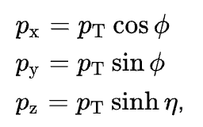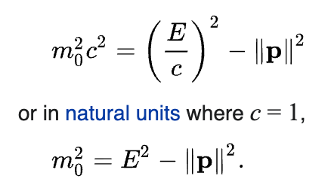[1]
- Plot weighted histograms for signal and background.
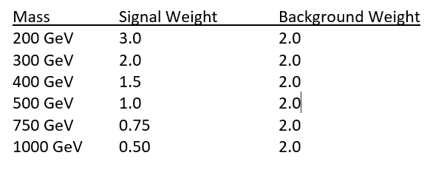[1]
- Get significance of different possible masses.
N_{signal} / $\sqrt{Nbackground}$ [1]

Results
- Figures show a clear peak centered near the corresponding Z’ mass.
- The optimal window sizes were found to be:
  - 200 GeV: $δ=8$
  - 300 GeV: $δ=10$
  - 400 GeV: $δ=8$
  - 500 GeV: $δ=10$
  - 750 GeV: $δ=10$
  - 1000 GeV: $δ=9$
- Maximum statistical significance values were obtained for each mass:
  - 200 GeV: 62.52
  - 300 GeV: 49.29
  - 400 GeV: 40.08
  - 500 GeV: 30.30
  - 750 GeV: 27.46
  - 1000 GeV: 18.74

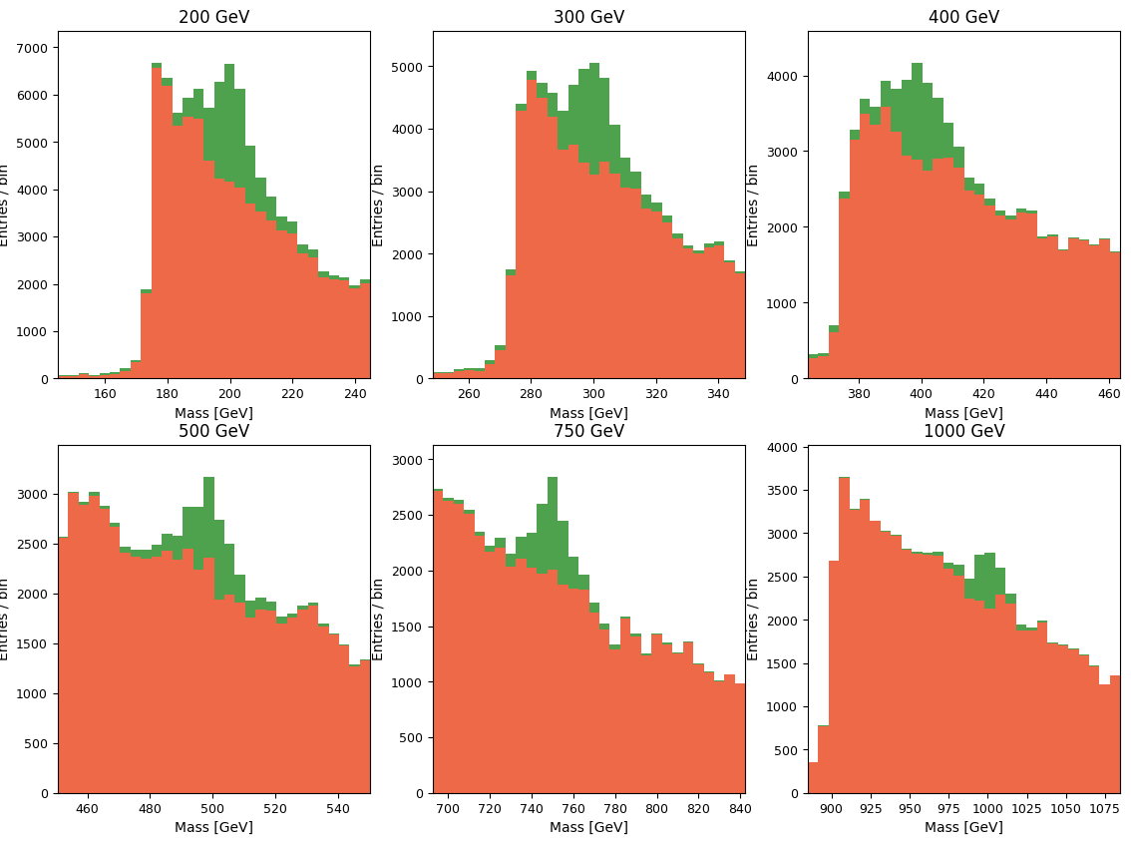
Analysis
- The significance curve as a function of $δ$shows a clear maximum for each mass hypothesis.
- The statistical significance decreases with increasing mass.
Discussion
- sensitivity reduced at higher energies.
Conclusions
- A systematic method for detecting a Z′ boson using invariant mass analysis was successfully developed.
- The optimal mass window for maximizing statistical significance is approximately 8–10 GeV across all tested masses.
- Histogram-based hypothesis comparison effectively highlights resonance structures.
References
[1] Physics 121W Lab Manual: “Optimizing the power of the LHC to search for a new heavy vector boson,” Prof. Whiteson, Spring 2025–26.

